Welcome to our chalet in the heart of the Dolomites!

It is our pleasure to welcome you here. We are delighted to have you with us. Make yourself comfortable, enjoy the special atmosphere of our hotel, and leave everyday life behind.

To help you upon your arrival and so that you can quickly find your way around, we have compiled a list of all the essential information you need to know for your stay, as well as the rules that apply during your stay.

We wish you a relaxing stay and unforgettable moments.

Your FMC team!

WIFI
All apartments are equipped with free high-speed internet. The password is:
Florisa-am-Rosengarten

Contents

1. Arrival, access, and exit 3
2. Access to the apartments 7
3. What is located where in the building? 9
4. Your apartment 10
5. Sauna 12
6. Whirlpool & outdoor area 13
7. Waste 16
8. Quiet hours and events 17
9. Photography and filming 17
10. Smoking 17
11. Interim cleaning and towels 17
12. Furnishings and damage 18
13. Guests and visitors 18
14. Pets 18
15. Contact 18

Arrival, access, and exit
The Florisa Mountain Penthouse is located at
Weisslahn 9, 39050 Tiers.
Upon arrival, please drive about 100 m past the chalet (see No. 1 below) and turn your car around to drive into the underground parking garage from above (see No. 2 below).
Please exit the garage the same way you entered. It is almost impossible and risky to drive directly into the underground garage coming from the valley or to drive out in this direction. We recommend that you drive directly into the underground garage upon arrival, as the apartments are only accessible from the garage, even on foot.

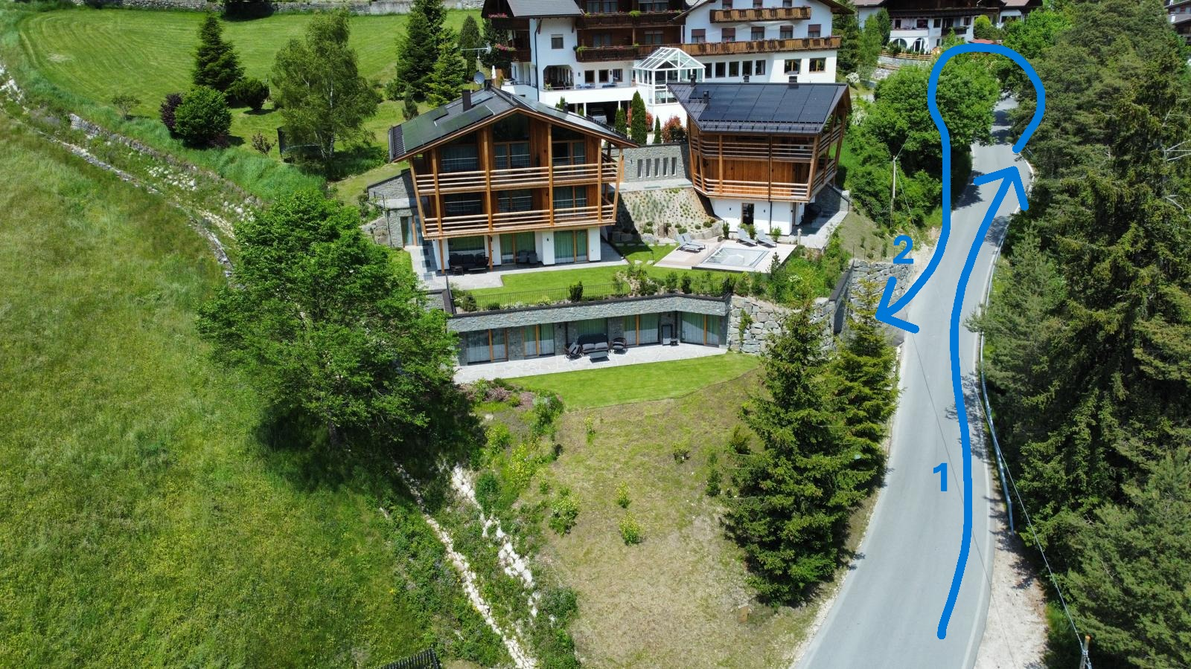

There is a code panel on the left-hand side of the entrance.
Please enter the access code that you will receive from us shortly before your arrival and always confirm it by checking the “checkmark”.
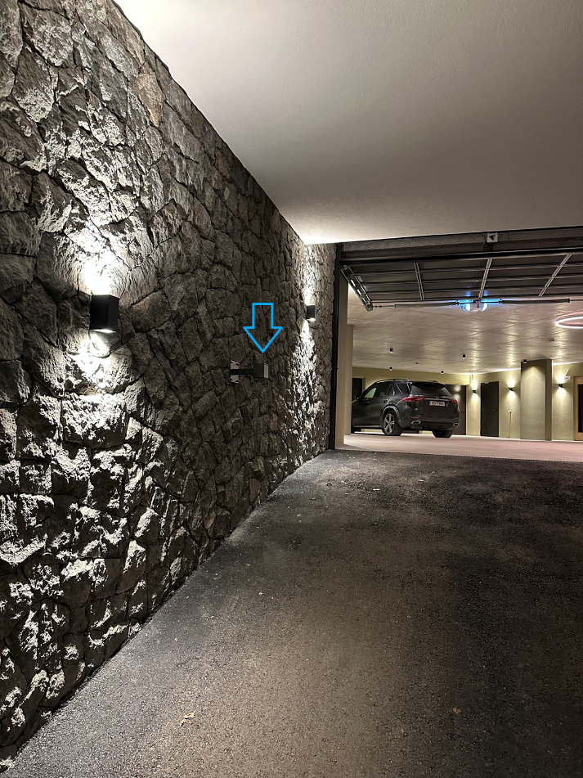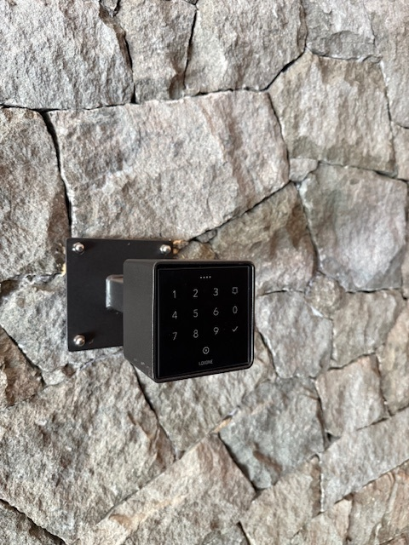

Alternatively, there is a door for pedestrians on the right-hand side of the entrance, also with a code keypad that works with your access code.
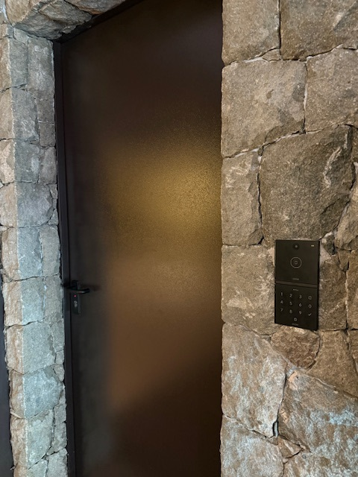

Parking
Please select one of the eight parking spaces in the garage and try not to block more than one parking space with your car.
Please also note that for security reasons, two video cameras are installed in the garage.

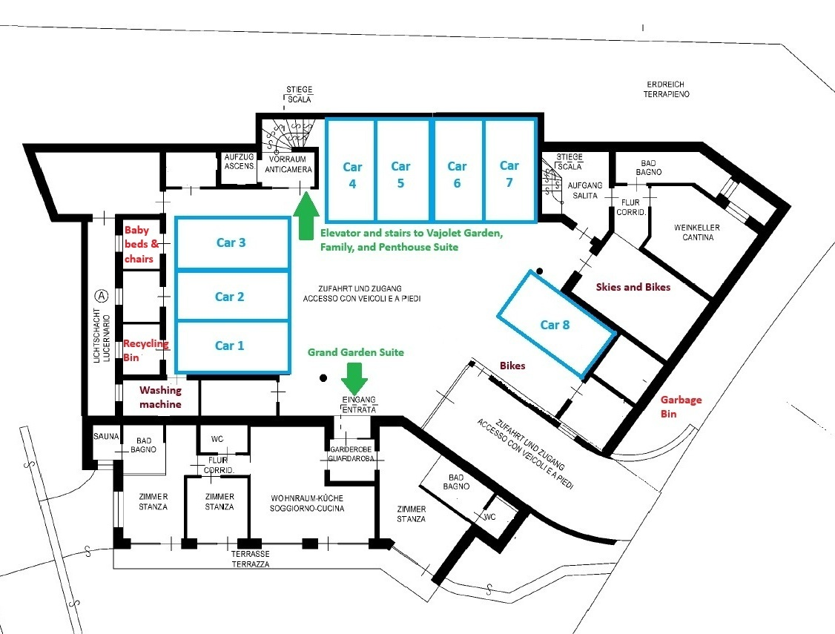

Exit
If you want to leave the underground garage with your vehicle, you will find a gate opener to the right of the garage door. Please press the green button. The gate will then open and close automatically after you have exited.
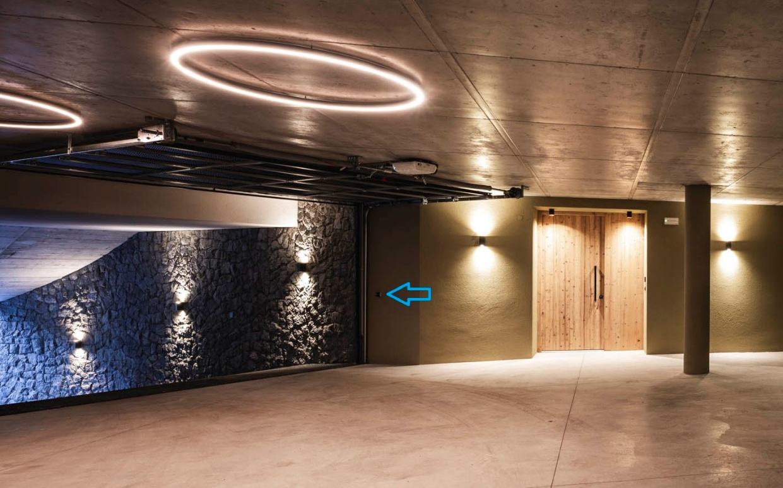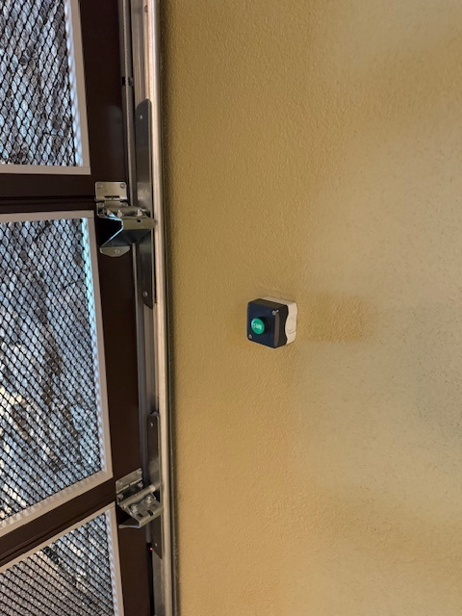

Charging electric cars
There are three charging stations for electric vehicles in the garage.
Please coordinate with other guests regarding usage if no charging space is available.

Bicycle and ski storage & charging e-bikes
On the map on page 4, we have marked the areas where you can store your skis and bicycles.

Please use the bike racks on the walls to store your bikes so that all guests can find a place for their bikes and the paths remain clear.

In the ski/bike room, you will find power outlets that you can use free of charge to charge your e-bikes.

On the wall, you will find a boot dryer that automatically dries your ski boots overnight.

Please make sure to keep the door to the ski and bike room closed at all times.

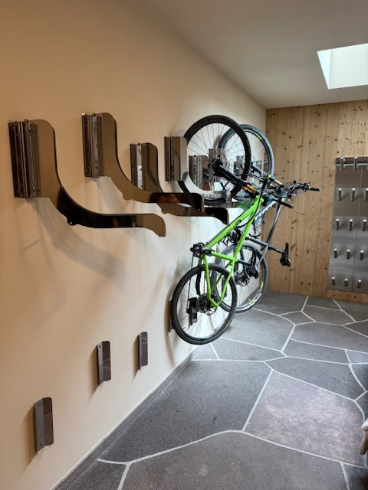

Access to the apartments
The map on page 4 shows the access route to the apartments. The apartments are only accessible via the underground car park.
The Grand Garden Suite is directly accessible from the garage, while the other apartments can be reached via the stairs or elevator behind the glass door in the garage.
You will receive an individual code to enter your apartment. With your individual code, you can also open all general access doors such as the garage, the door to the pool, etc. Please do not share the code with other guests or unknown persons.
The code is valid from the day of your arrival until the day of your departure. Please note that your code is only valid from the agreed check-in time on days when there is a booking immediately before your stay, and only until the agreed check-out time on days when there is a booking immediately after your stay at.
All relevant doors have a keypad for entering the access code, such as the one shown above for the garage entrance.

Check-in
Your apartment will be available from 4:00 p.m. on the day of arrival.
After you have completed the online check-in, we will send you the access code. No further check-in on site is required.

Check-out
Please vacate the apartment by 10:00 a.m. on the day of your departure.
Please put dirty dishes in the dishwasher before you leave and empty your trash can.
No separate check-out is required.

Winter late check-out
Upon request and for an additional fee, a "winter late check-out" is available for skiers in winter.
This gives you extended access to the underground parking garage, ski storage room, and day toilet with shower until 5:00 p.m.

What is located where in the building?

Underground parking level (see also map on page 4):
- Entrance/access to the street
- Bread box
- Ski and bicycle room
- Storage room for baby cots and high chairs
- Recycling room / recycling containers
- Household waste (outside in front of the building)
- Grand Garden Suite
- Laurin Garden Suite
- Washing machine (upon request only)
- Wine cellar (upon request only)

Ground floor:
- Vajolet Garden Suite
- Laurin Garden Suite
- Whirlpool
- Florisa Shop (not yet open)

First floor:
- Family Suite

Second floor:
- Penthouse Suite

Your apartment
Our spacious apartments offer plenty of room for relaxation and privacy. Each apartment has its own Finnish sauna, and the shared, year-round heated whirlpool in the garden invites you to relax in the fresh air after an eventful day.
Main switch
At the entrance to your apartment, you will find a main switch (indicated by a small red light). Use this to turn on the power.
Please use this switch to turn off the power when leaving the apartment. The refrigerator and cleaning robot will continue to function.
Kitchen
Your apartment has a fully equipped kitchen.
Upon arrival, you will find the following consumables in the kitchen:
- Dishwasher tablets
- Garbage bags
- Dishcloth
- Dish sponge
- Dishwashing liquid
- Hand soap
Please note that we do not provide Nespresso capsules for the coffee machine. We kindly ask you to bring your own.

Cleaning robot
Your apartment is equipped with a robot vacuum cleaner.
You are free to use it during your stay. Just make sure that the water tank is filled with water (do not add any cleaning agent except for a capful of parquet cleaner, if available) and that the waste tank is empty before switching it on.
To use it, make sure it is charged and press the ON button – the robot will confirm that it is starting to clean. It knows the floor plan of the apartment and cleans all rooms as long as the doors are open.

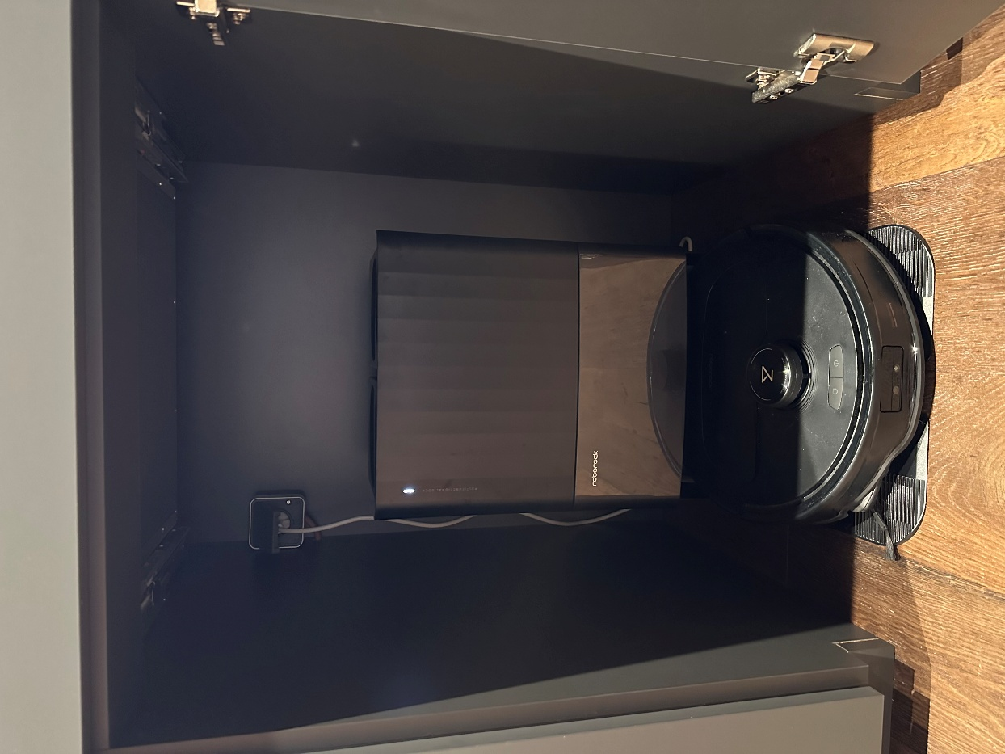

Cribs and high chairs
We have several portable cribs, including mattresses and bedding, in the storage room near the underground parking garage (see map on page 4). There are also several high chairs for children up to about three years of age.
For logistical reasons, we are sometimes unable to provide these in your apartment upon arrival. In this case, we ask you to pick them up in the basement and bring them to your apartment.

Emergencies & Other Equipment
You will find the following useful items in the wardrobe of your apartment:
- Fire extinguisher
- First aid kit
- Clothes drying rack
- Iron
- Ironing board
Note: In case of fire, please do not use the elevator. Leave the building via the stairwells.
The emergency number is 112.

Air conditioning
The Florisa Mountain Chalet has a climate-friendly geothermal heat pump that is also connected to a PV system. This is used to heat the building centrally via underfloor heating during the cold months or to cool it during the warm months. Individual control by guests is not possible.

Sauna
The Grand Garden Suite, Vajolet Garden Suite, and Penthouse Suite each have a private indoor Finnish sauna. You can easily turn it on by turning the knob inside the sauna to the desired temperature. Operation is indicated by a red LED light. If you want to turn off the sauna, simply turn the knob to the "off" position.
The Family Suite and Laurin Garden Suite each have a private outdoor Finnish sauna. These saunas can be switched on and set to the desired temperature using the digital control panel inside the sauna.
It takes approx. 45-60 minutes for your sauna to reach the desired temperature.
If you forget to turn off the sauna, it will automatically switch off after 2.5 hours.
Your sauna is a place of health and well-being. Please observe the 7 basic rules for a stress-free, relaxing sauna experience:
- Before using the sauna, you should shower with soap, wash off any deodorant or perfume residue, and remove your makeup. This will prepare your skin and hair for the sauna.
- Before sitting down in the sauna, you should spread out your sauna towel as a mat to lie or sit on (!). When using the sauna, make sure that you are sitting or lying completely on the towel. This protects the sauna benches from sweat and other contaminants, but is also important for hygienic reasons, as it prevents the spread of skin infections or fungi.
- We recommend entering the sauna without any clothing, i.e. without swimwear. Swimwear can overheat the skin and prevent sweat from evaporating, which can lead to skin irritation. Even more seriously, at high temperatures, synthetic fabrics in particular can release unpleasant odors and harmful substances.
- Drink plenty of water before and after using the sauna.
- Do not take any drinks, especially glasses or glass bottles, into the sauna.
- Avoid visiting the sauna if you have a cold.
- Cool down slowly between sauna sessions and allow plenty of time before your next session.
- ATTENTION: Children under the age of 16 may only use the sauna when accompanied by an adult.

Whirlpool & outdoor area
On the ground floor, one floor above the garage, you will find our beautiful heated outdoor pool with a sun deck – in summer also with deck chairs.
The water is heated to 28-32 degrees in summer and 34-36 degrees in winter.
You can control the massage jets and whirlpool functions directly at the pool.
The outdoor shower is only in operation from the end of May to mid-October.

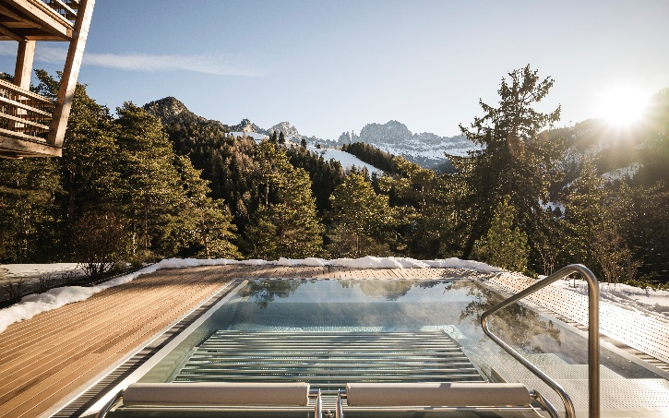

Use is free of charge and operating hours are generally from approximately 5:00 p.m. to 8:00 p.m. (start is earlier in summer). The pool is filled and emptied automatically and cannot be controlled by guests.
Please note that dogs are not allowed in this outdoor area.
We would like to point out that the whirlpool and sun deck areas are monitored by video camera for security reasons.

Please also respect the privacy of other guests when using the outdoor area:
The following areas are designated as common areas for all guests:
- sun deck,
- the whirlpool,
- the outdoor shower, and the
- garden area between the whirlpool and the entrance to the chalet.
The adjacent garden and terrace areas belong to the respective apartments and are their private areas. Please do not go onto the terraces or into the garden in front of these two apartments unless you are a guest there.

Rules for using the hot tub to ensure your safety, comfort, and hygiene
- The hot tub is unsupervised.
- Children are only allowed to use the hot tub under the supervision of a parent or guardian.
- Access is via a wooden deck and steps, which may be slippery or icy, especially in winter. Please take appropriate care.
- Access to the hot tub is prohibited for persons who are drunk, obviously unclean, or suffering from an illness.
- Please do not jump into the hot tub.
- Please maintain hygiene in the hot tub.
In particular,
  - it is important to shower before using the whirlpool
  - sunscreen, oils, soaps, shampoos, and bath salts are prohibited in the whirlpool.
  - please ensure that your small children go to the toilet before using the whirlpool.
  - it is prohibited to bring glass objects or containers into the hot tub or its surroundings
  - bulky or sharp objects are not allowed in the hot tub.
  - please do not leave any objects in the hot tub that could clog the filter system.
- During thunderstorms, it is dangerous to use the hot tub or stay near it or in the garden, and therefore it is not permitted.
- Health:
  - Depending on the individual, using a hot tub may have health consequences. We strongly advise users to be cautious and consult their doctor about how to use it.
  - During pregnancy, using a hot tub can be harmful to the fetus.
  - If you have health problems (cardiovascular problems, diabetes, obesity, etc.), seek advice before using the hot tub.
  - If you have skin lesions, refrain from using the hot tub.
  - Heat intensifies the effects of medication and alcohol and can lead to unconsciousness. Please leave the hot tub immediately if you feel tired or sleepy.
Use of the whirlpool is at your own risk.
In the event of damage to the equipment or use that does not comply with the above rules, the repair and cleaning costs will be charged to the guest.

Waste
Waste separation is an important issue in South Tyrol, and we ask you to comply with local regulations.
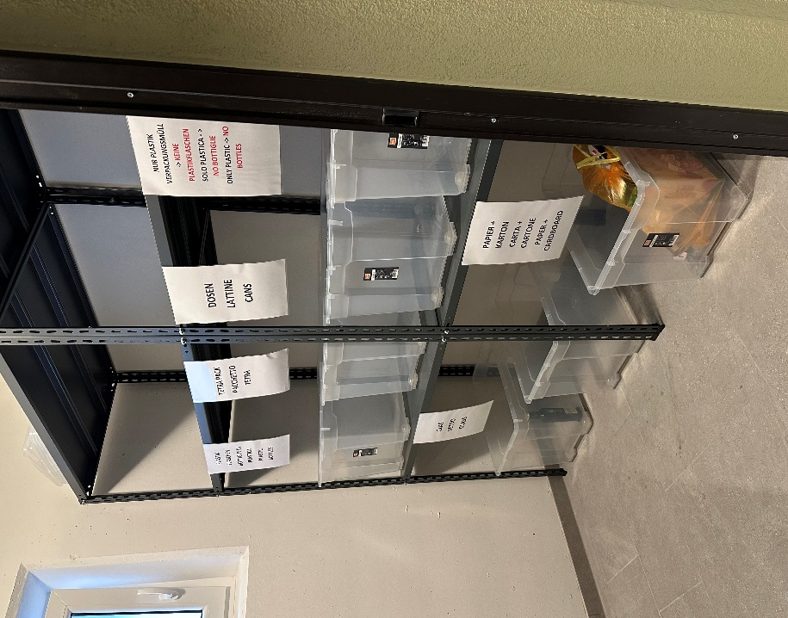
Please bring your
- plastic bottles,
- glass,
- paper/cardboard
to the recycling room in the garage area, as indicated on the map above.
There you will find appropriate collection containers for recyclable materials.

Please take only the rest of your trash, including organic waste, to the trash cans in front of the building at the entrance.

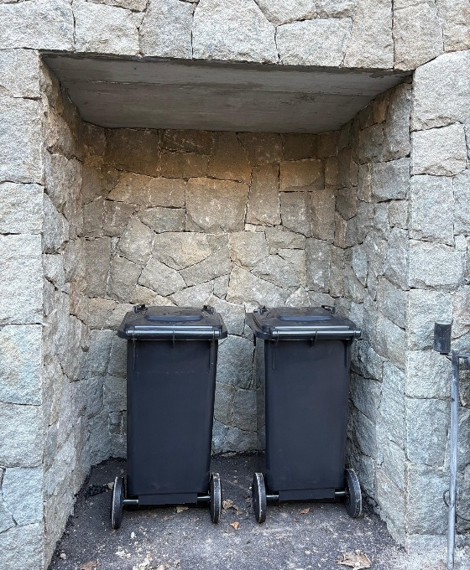

Quiet hours and events
Please respect the quiet hours from 10:00 p.m. to 7:00 a.m.
Avoid loud music or noisy activities, especially in the evening hours. Parties and loud events are not permitted. Exceptions may be made if these are agreed with us in advance of your stay and approved by us.

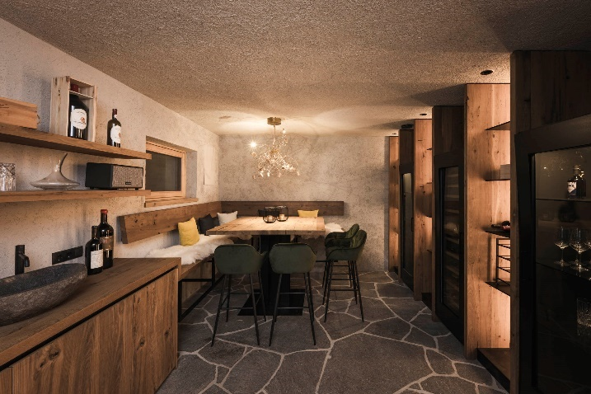
Our wine cellar can be booked for special occasions and celebrations.
Please contact us in advance to make arrangements.

Photography and filming
When taking photos and filming on the premises, please respect the privacy of other guests. Commercial photography and filming on the premises and in our buildings is prohibited.

Smoking
Smoking is not permitted in the buildings (including e-cigarettes, vaping, etc.). Smoking is permitted on your balcony or terrace.

Interim cleaning and towels
For stays of 11 days or more, we offer the option of interim cleaning and towel replacement upon request.

Furnishings and damage
We make every effort to create an incomparable, pleasant living environment for you. We ask you to treat the furnishings and furniture with care so that guests after you can enjoy the same experience. You are liable for any damage you cause. If any damage occurs, please inform us immediately via WhatsApp, preferably with an additional photo.
We also ask you to notify us immediately if you find that any items are missing.

Guests and visitors
Please inform us in advance if additional visitors wish to stay overnight. Due to legal regulations, these must be reported to the authorities in all cases, as with all other guests. Furthermore, such overnight stays are only possible if the maximum number of guests per apartment is not exceeded.

Pets
We do not allow pets, with the exception of dogs. If you have given us advance notice, you may bring a dog with you to certain apartments. Please note the rules for staying with a dog, which you will receive separately in our "Dog Stay Etiquette Guide."

Contact
If you have any comments or questions, we will be happy to assist you. You can reach us
- by email: info@florisa.it

- and via WhatsApp: +49 171 6480031
We have curated a selection of tips and recommendations for your stay in our "Guest Guide", which you receive separately.
Please note that we do not offer reception or concierge services. Accordingly, we do not make restaurant reservations or similar arrangements.

